Bonjour 😊 I have set you all up with your own Duolingo school account.

Duolingo is a great language programme which allows you to practise a language whenever/wherever you like AND at your own speed. It practises listening, speaking, reading and writing.

Some of you already have your own personal account but this is a separate one set up by your school. It will allow me to monitor your progress and set you challenges and assignments. It will also allow you to compete against each other.
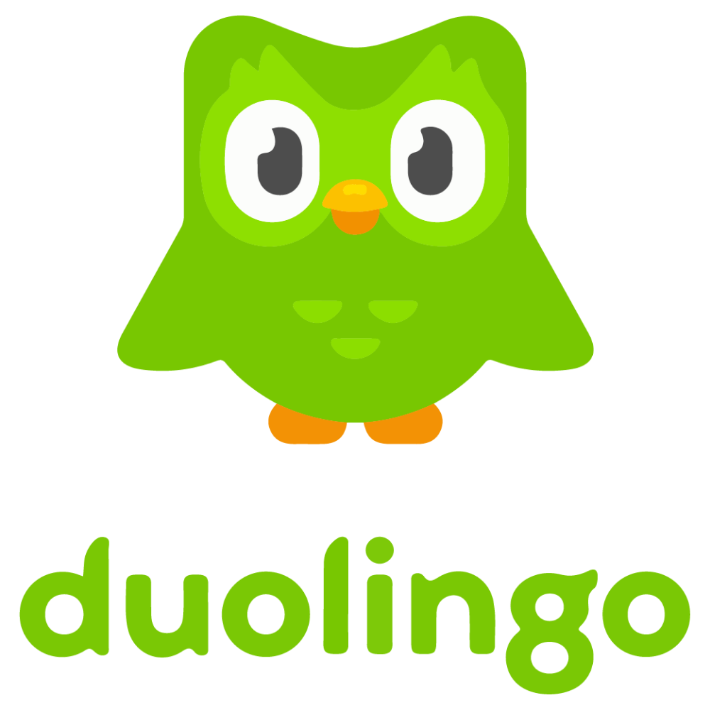
These are the instructions to get setup!

If you are on a computer:
1. Go to www.duolingo.com
2. Click Login
3. Type in your username and password and click Login.

If you are on a smartphone or tablet:
1. Download the Duolingo app and open it up
2. Press I Already Have an Account
3. Type in your username and password and tap Sign In.

Once you are signed in you can do as much or as little as you like, you can gain points for work done and lose hearts when you forget to do it (so maybe set a timer to remind yourself to do it each day). It doesn’t have to be done in order so pick and choose as you go along. Have a play with it and I will explain more when I see you in the Teams lesson 😊
Bonne Chance (= Good Luck)
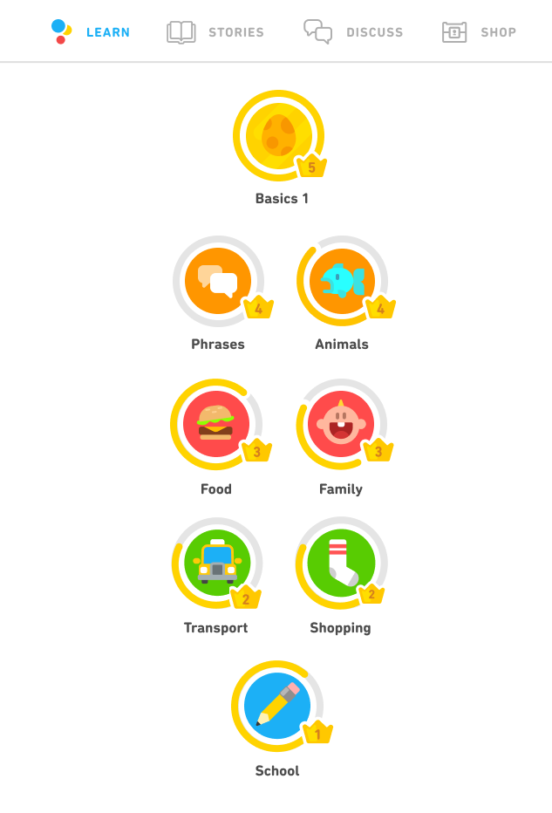
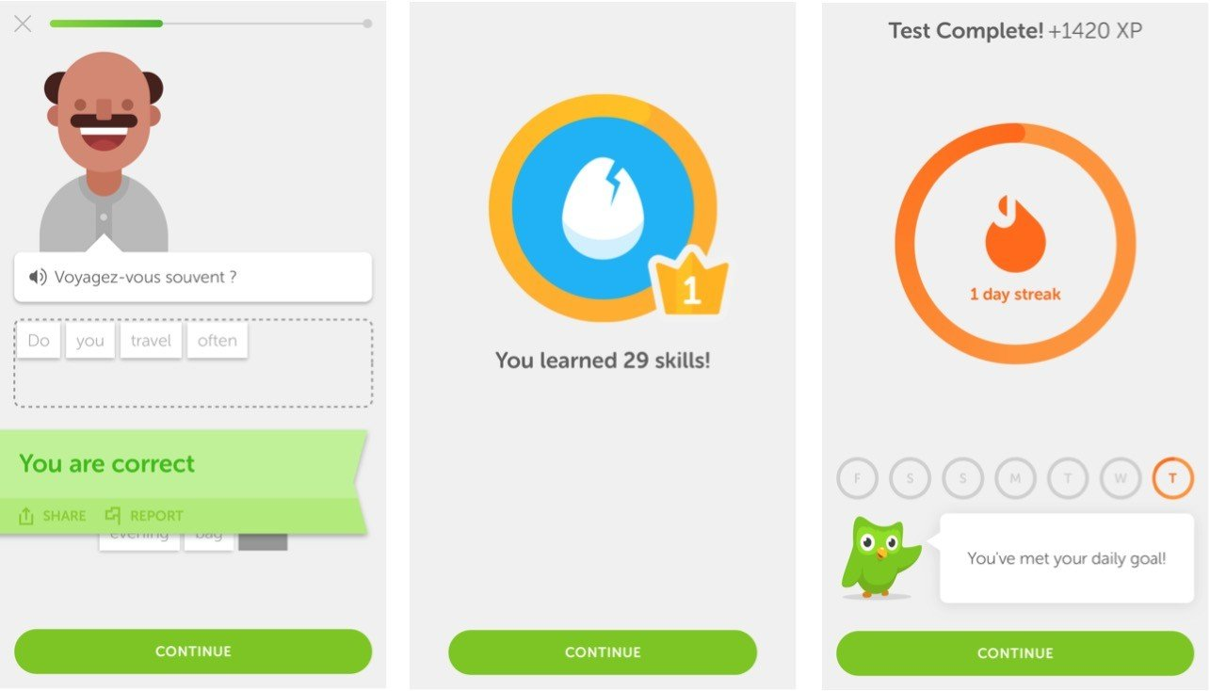
Madame Heap

