Is it a Bird? Is it a Plane?
- Choose a major city from each continent and look at the population’s primary mode of public transport, e.g. rickshaws and Sky train in Bangkok, Asia, the Tube in London, Europe etc.
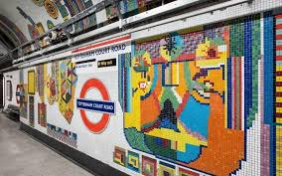
- Create a fact-sheet showing each city’s most popular mode of transport and decide which is your favourite, providing reasons for your opinions.

