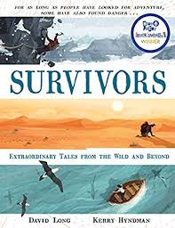
- Read from page 155, ‘ Lying around seventy miles from the nearest road…’ to the end.
- Rasmussen is clearly passionate about his job as he flew the plane in the first place without waiting for a pilot. He was even thinking about his job when he had given up hope of being rescued. Rasmussen’s work is the longest anyone has spent on a conservation project.
- Can you think of something to do with wildlife or the environment that you would like to preserve?
- What steps do you think you would need to take in order to make a real difference like Rasmussen did with the painted dogs?

